**Manage Azure Pipeline agents and pools**

**Manage Azure Pipeline agents and pools**

* 1 hr 17 min
* Module
* 13 Units

Feedback

Advanced

Administrator

Developer

DevOps Engineer

Security Engineer

Security Operations Analyst

Service Adoption Specialist

Solution Architect

Technology Manager

Azure

Azure Artifacts

Azure Boards

Azure Cloud Services

Azure DevOps

Azure Pipelines

Azure Repos

Azure Test Plans

GitHub

This module explores the differences between Microsoft-hosted and self-hosted agents, details job types, and configures agent pools. Understand typical situations to use agent pools and how to manage their security.

**Learning objectives**

By the end of this module, you're able to:

* Choose between Microsoft-hosted and self-hosted agents.
* Install and configure Azure Pipelines Agents.
* Configure agent pools.
* Make the agents and pools secure.
* Explore communication to deploy using Azure Pipelines.

[**Start**](https://learn.microsoft.com/en-us/training/modules/manage-azure-pipeline-agents-pools/1-introduction/)Add

**Prerequisites**

None

**This module is part of these learning paths**

* [AZ-400: Implement CI with Azure Pipelines and GitHub Actions](https://learn.microsoft.com/training/paths/az-400-implement-ci-azure-pipelines-github-actions/)

**Module assessment**

Assess your understanding of this module. Sign in and answer all questions correctly to earn a pass designation on your profile.

[**Take the module assessment**](https://learn.microsoft.com/training/modules/manage-azure-pipeline-agents-pools/12-knowledge-check/)

* [Introduction](https://learn.microsoft.com/en-us/training/modules/manage-azure-pipeline-agents-pools/1-introduction)1 min
* [Choose between Microsoft-hosted versus self-hosted agents](https://learn.microsoft.com/en-us/training/modules/manage-azure-pipeline-agents-pools/2-choose-between-microsoft-hosted-versus-self-hosted-agents)3 min
* [Explore job types](https://learn.microsoft.com/en-us/training/modules/manage-azure-pipeline-agents-pools/3-explore-job-types)2 min
* [Introduction to agent pools](https://learn.microsoft.com/en-us/training/modules/manage-azure-pipeline-agents-pools/4-introduction-to-agent-pools)1 min
* [Explore predefined agent pool](https://learn.microsoft.com/en-us/training/modules/manage-azure-pipeline-agents-pools/5-explore-predefined-agent-pool)1 min
* [Understand typical situations for agent pools](https://learn.microsoft.com/en-us/training/modules/manage-azure-pipeline-agents-pools/6-understand-typical-situations-for-agent-pools)3 min
* [Communicate with Azure Pipelines](https://learn.microsoft.com/en-us/training/modules/manage-azure-pipeline-agents-pools/7-communicate-with-azure-pipelines)4 min
* [Communicate to deploy to target servers](https://learn.microsoft.com/en-us/training/modules/manage-azure-pipeline-agents-pools/8-communicate-to-deploy-to-target-servers)2 min
* [Examine other considerations](https://learn.microsoft.com/en-us/training/modules/manage-azure-pipeline-agents-pools/9-examine-other-considerations)5 min
* [Describe security of agent pools](https://learn.microsoft.com/en-us/training/modules/manage-azure-pipeline-agents-pools/10-describe-security-of-agent-pools)4 min
* [Configure agent pools and understand pipeline styles](https://learn.microsoft.com/en-us/training/modules/manage-azure-pipeline-agents-pools/11-configure-agent-pools-understand-pipeline-styles)45 min
* [Knowledge check](https://learn.microsoft.com/en-us/training/modules/manage-azure-pipeline-agents-pools/12-knowledge-check)5 min
* [Summary](https://learn.microsoft.com/en-us/training/modules/manage-azure-pipeline-agents-pools/13-summary)1 min

**Introduction**

Completed100 XP

* 1 minute

This module explores the differences between Microsoft-hosted and self-hosted agents, detail job types, and introduces agent pool configuration. Understand typical situations to use agent pools and how to manage their security.

**Learning objectives**

After completing this module, students and professionals can:

* Choose between Microsoft-hosted and self-hosted agents.
* Install and configure Azure Pipelines Agents.
* Configure agent pools.
* Make the agents and pools secure.

**Prerequisites**

* Understanding of what DevOps is and its concepts.
* Familiarity with version control principles is helpful but isn't necessary.
* Beneficial to have experience in an organization that delivers software.

**Next unit: Choose between Microsoft-hosted versus self-hosted agents**

[**Next**](https://learn.microsoft.com/en-us/training/modules/manage-azure-pipeline-agents-pools/2-choose-between-microsoft-hosted-versus-self-hosted-agents/)

**Choose between Microsoft-hosted versus self-hosted agents**

Completed100 XP

* 3 minutes

To build your code or deploy your software, you generally need at least one agent.

As you add more code and people, you'll eventually need more.

When your build or deployment runs, the system begins one or more jobs.

An agent is an installable software that runs one build or deployment job at a time.

**Microsoft-hosted agent**

If your pipelines are in Azure Pipelines, then you've got a convenient option to build and deploy using a Microsoft-hosted agent.

With a Microsoft-hosted agent, maintenance and upgrades are automatically done.

Each time a pipeline is run, a new virtual machine (instance) is provided. The virtual machine is discarded after one use.

For many teams, this is the simplest way to build and deploy.

You can try it first and see if it works for your build or deployment. If not, you can use a self-hosted agent.

A Microsoft-hosted agent has job time limits.

**Self-hosted agent**

An agent that you set up and manage on your own to run build and deployment jobs is a self-hosted agent.

You can use a self-hosted agent in Azure Pipelines. A self-hosted agent gives you more control to install dependent software needed for your builds and deployments.

You can install the agent on:

* Linux.
* macOS.
* Windows.
* Linux Docker containers.

After you've installed the agent on a machine, you can install any other software on that machine as required by your build or deployment jobs.

A self-hosted agent doesn't have job time limits.

**Next unit: Explore job types**

**Explore job types**

Completed100 XP

* 2 minutes

In Azure DevOps, there are four types of jobs available:

* Agent pool jobs.
* Container jobs.
* Deployment group jobs.
* Agentless jobs.

**Agent pool jobs**

The most common types of jobs. The jobs run on an agent that is part of an agent pool.

**Container jobs**

Similar jobs to Agent Pool Jobs run in a container on an agent part of an agent pool.

**Deployment group jobs**

Jobs that run on systems in a deployment group.

**Agentless jobs**

Jobs that run directly on the Azure DevOps. They don't require an agent for execution. It's also-often-called Server Jobs.

**Next unit: Introduction to agent pools**

**Introduction to agent pools**

Completed100 XP

* 1 minute

Instead of managing each agent individually, you organize agents into agent pools. An agent pool defines the sharing boundary for all agents in that pool.

In Azure Pipelines, pools are scoped to the entire organization so that you can share the agent machines across projects.

If you create an Agent pool for a specific project, only that project can use the pool until you add the project pool into another project.

When creating a build or release pipeline, you can specify which pool it uses, organization, or project scope.

Pools scoped to a project can only use them across build and release pipelines within a project.

To share an agent pool with multiple projects, use an organization scope agent pool and add them in each of those projects, add an existing agent pool, and choose the organization agent pool. If you create a new agent pool, you can automatically grant access permission to all pipelines.

**Next unit: Explore predefined agent pool**

**Explore predefined agent pool**

Completed100 XP

* 1 minute

Azure Pipelines provides a pre-defined agent pool-named **Azure Pipelines** with Microsoft-hosted agents.

It will often be an easy way to run jobs without configuring build infrastructure.

The following virtual machine images are provided by default:

* Windows Server 2022 with Visual Studio 2022.
* Windows Server 2019 with Visual Studio 2019.
* Ubuntu 20.04.
* Ubuntu 18.04.
* macOS 11 Big Sur.
* macOS X Catalina 10.15.

By default, all contributors in a project are members of the User role on each hosted pool.

It allows every contributor to author and run build and release pipelines using a Microsoft-hosted pool.

Pools are used to run jobs. Learn about [specifying pools for jobs](https://learn.microsoft.com/en-us/azure/devops/pipelines/process/phases).

**Note**

See Microsoft-hosted agents for the most up-to-date list of Agent Pool Images. Also, the complete list of software installed on these machines.

**Next unit: Understand typical situations for agent pools**

**Understand typical situations for agent pools**

Completed100 XP

* 3 minutes

If you've got many agents intended for different teams or purposes, you might want to create more pools, as explained below.

**Create agent pools**

Here are some typical situations when you might want to create agent pools:

* You're a project member, and you want to use a set of machines your team owns for running build and deployment jobs.
  + First, make sure you're a member of a group in All Pools with the Administrator role.
  + Next, create a New project agent pool in your project settings and select the option to Create a new organization agent pool. As a result, both an organization and project-level agent pool will be created.
  + Finally, install and configure agents to be part of that agent pool.
* You're a member of the infrastructure team and would like to set up a pool of agents for use in all projects.
  + First, make sure you're a member of a group in All Pools with the Administrator role.
  + Next, create a New organization agent pool in your admin settings and select Autoprovision corresponding project agent pools in all projects while creating the pool. This setting ensures all projects have a pool pointing to the organization agent pool. The system creates a pool for existing projects, and in the future, it will do so whenever a new project is created.
  + Finally, install and configure agents to be part of that agent pool.
* You want to share a set of agent machines with multiple projects, but not all of them.
  + First, create a project agent pool in one of the projects and select the option to Create a new organization agent pool while creating that pool.
  + Next, go to each of the other projects, and create a pool in each of them while selecting the option to Use an existing organization agent pool.
  + Finally, install and configure agents to be part of the shared agent pool.

**Next unit: Communicate with Azure Pipelines**

**Communicate with Azure Pipelines**

Completed100 XP

* 4 minutes

The agent communicates with Azure Pipelines to determine which job to run and reports the logs and job status.

The agent always starts this communication. All the messages from the agent to Azure Pipelines over HTTPS depend on how you configure the agent.

This pull model allows the agent to be configured in different topologies, as shown below.

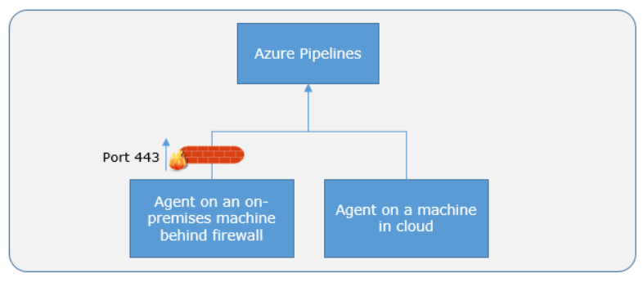

Here's a standard communication pattern between the agent and Azure Pipelines.

The user registers an agent with Azure Pipelines by adding it to an agent pool. You must be an agent pool administrator to register an agent. The identity of the agent pool administrator is needed only at the time of registration. It isn't persisted on the agent or used to communicate further between the agent and Azure Pipelines.

Once the registration is complete, the agent downloads a listener OAuth token and uses it to listen to the job queue.

Periodically, the agent checks to see if a new job request has been posted in the job queue in Azure Pipelines. The agent downloads the job and a job-specific OAuth token when a job is available. Azure Pipelines generate this token for the scoped identity specified in the pipeline. That token is short-lived and is used by the agent to access resources (for example, source code) or modify resources (for example, upload test results) on Azure Pipelines within that job.

Once the job is completed, the agent discards the job-specific OAuth token and checks if there's a new job request using the listener OAuth token.

The payload of the messages exchanged between the agent and Azure Pipelines are secured using asymmetric encryption. Each agent has a public-private key pair, and the public key is exchanged with the server during registration.

The server uses the public key to encrypt the job's payload before sending it to the agent. The agent decrypts the job content using its private key. Secrets stored in build pipelines, release pipelines, or variable groups are secured when exchanged with the agent.

**Next unit: Communicate to deploy to target servers**

**Communicate to deploy to target servers**

Completed100 XP

* 2 minutes

When you use the agent to deploy artifacts to a set of servers, it must-have "line of sight" connectivity to those servers.

The Microsoft-hosted agent pools, by default, have connectivity to Azure websites and servers running in Azure.

Suppose your on-premises environments don't have connectivity to a Microsoft-hosted agent pool (because of intermediate firewalls). In that case, you'll need to manually configure a self-hosted agent on the on-premises computer(s).

The agents must have connectivity to the target on-premises environments and access to the Internet to connect to Azure Pipelines or Azure DevOps Server, as shown in the following diagram.

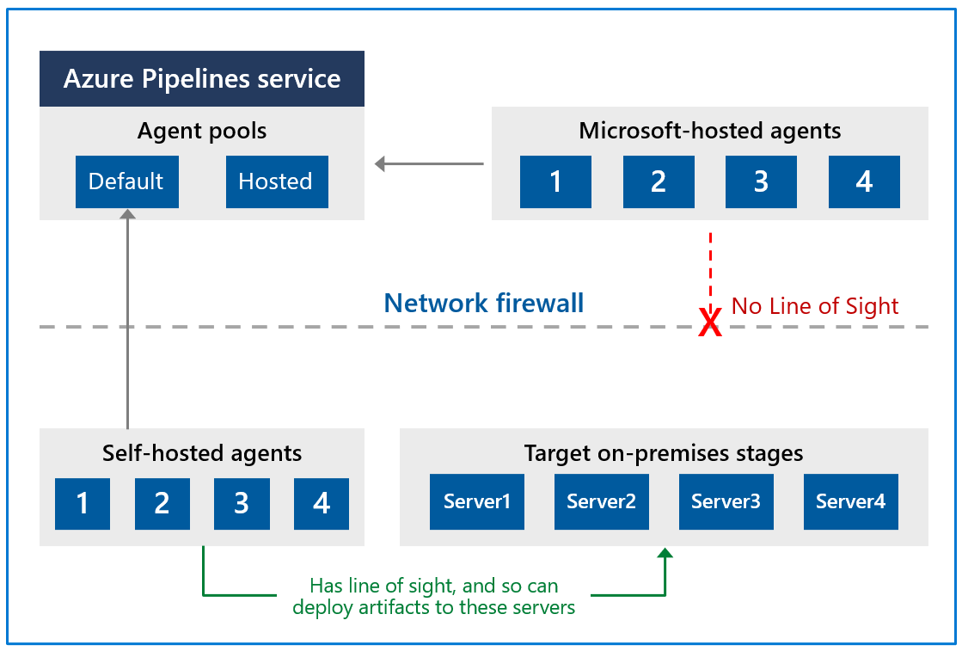

**Next unit: Examine other considerations**

**Examine other considerations**

Completed100 XP

* 5 minutes

**Authentication**

To register an agent, you need to be a member of the administrator role in the agent pool.

The identity of the agent pool administrator is only required at the time of registration. It's not persisted on the agent and isn't used in any following communication between the agent and Azure Pipelines.

Also, you must be a local administrator on the server to configure the agent.

Your agent can authenticate to Azure DevOps using one of the following methods:

**Personal access token (PAT)**

Generate and use a PAT to connect an agent with Azure Pipelines. PAT is the only scheme that works with Azure Pipelines. Also, as explained above, this PAT is used only when registering the agent and not for succeeding communication.

**Interactive versus service**

You can run your agent as either a service or an interactive process. Whether you run an agent as a service or interactively, you can choose which account you use to run the agent.

It's different from your credentials when registering the agent with Azure Pipelines. The choice of agent account depends solely on the needs of the tasks running in your build and deployment jobs.

For example, to run tasks that use Windows authentication to access an external service, you must run the agent using an account with access to that service.

However, if you're running UI tests such as Selenium or Coded UI tests that require a browser, the browser is launched in the context of the agent account.

After configuring the agent, we recommend you first try it in interactive mode to ensure it works. Then, we recommend running the agent in one of the following modes so that it reliably remains to run for production use. These modes also ensure that the agent starts automatically if the machine is restarted.

You can use the service manager of the operating system to manage the lifecycle of the agent. Also, the experience for auto-upgrading the agent is better when it's run as a service.

As an interactive process with autologon enabled. In some cases, you might need to run the agent interactively for production use, such as UI tests.

When the agent is configured to run in this mode, the screen saver is also disabled.

Some domain policies may prevent you from enabling autologon or disabling the screen saver.

In such cases, you may need to seek an exemption from the domain policy or run the agent on a workgroup computer where the domain policies don't apply.

**Note**

There are security risks when you enable automatic login or disable the screen saver. You allow other users to walk up to the computer and use the account that automatically logs on. If you configure the agent to run in this way, you must ensure the computer is physically protected; for example, located in a secure facility. If you use Remote Desktop to access the computer on which an agent is running with autologon, simply closing the Remote Desktop causes the computer to be locked, and any UI tests that run on this agent may fail. To avoid this, use the tscon command to disconnect from Remote Desktop.

**Agent version and upgrades**

Microsoft updates the agent software every few weeks in Azure Pipelines.

The agent version is indicated in the format {major}.{minor}. For instance, if the agent version is 2.1, the major version is 2, and the minor version is 1.

When a newer version of the agent is only different in minor versions, it's automatically upgraded by Azure Pipelines.

This upgrade happens when one of the tasks requires a newer version of the agent.

If you run the agent interactively or a newer major version of the agent is available, you must manually upgrade the agents. Also, you can do it from the agent pools tab under your project collection or organization.

You can view the version of an agent by navigating to Agent pools and selecting the Capabilities tab for the wanted agent.

CmdCopy

Azure Pipelines: [https://dev.azure.com/{your_organization}/_admin/_AgentPool](https://dev.azure.com/{your_organization}/_admin/_AgentPool)

**Question and Answer**

**Do self-hosted agents have any performance advantages over Microsoft-hosted agents?**

In many cases, yes. Specifically:

* If you use a self-hosted agent, you can run incremental builds. For example, you define a CI build pipeline that doesn't clean the repo or do a clean build. Your builds will typically run faster.
  + You don't get these benefits when using a Microsoft-hosted agent. The agent is destroyed after the build or release pipeline is completed.
* A Microsoft-hosted agent can take longer to start your build. While it often takes just a few seconds for your job to be assigned to a Microsoft-hosted agent, it can sometimes take several minutes for an agent to be allocated, depending on the load on our system.

**Can I install multiple self-hosted agents on the same machine?**

Yes. This approach can work well for agents who run jobs that don't consume many shared resources. For example, you could try it for agents that run releases that mostly orchestrate deployments and don't do much work on the agent itself.

In other cases, you might find that you don't gain much efficiency by running multiple agents on the same machine.

For example, it might not be worthwhile for agents that run builds that consume many disks and I/O resources.

You might also have problems if parallel build jobs use the same singleton tool deployment, such as npm packages.

For example, one build might update a dependency while another build is in the middle of using it, which could cause unreliable results and errors.

Further instructions on how to set up self-hosted agents can be found at:

* [Self-hosted Windows agents](https://learn.microsoft.com/en-us/azure/devops/pipelines/agents/v2-windows).
* [Run a self-hosted agent behind a web proxy.](https://learn.microsoft.com/en-us/azure/devops/pipelines/agents/proxy)

**Next unit: Describe security of agent pools**

**Describe security of agent pools**

Completed100 XP

* 4 minutes

Understanding how security works for agent pools helps you control sharing and use of agents.

**Azure Pipelines**

In Azure Pipelines, roles are defined on each agent pool. Membership in these roles governs what operations you can do on an agent pool.

**Note**

There are differences between **Organization** and **Project** agent pools.

Expand table

| **Role on an organization agent pool** | **Purpose** |
| --- | --- |
| Reader | Members of this role can view the organization's agent pool and agents. You typically use it to add operators that are responsible for monitoring the agents and their health. |
| Service Account | Members of this role can use the organization agent pool to create a project agent pool in a project. If you follow the guidelines above for creating new project agent pools, you typically don't have to add any members here. |
| Administrator | Also, with all the above permissions, members of this role can register or unregister agents from the organization's agent pool. They can also refer to the organization agent pool when creating a project agent pool in a project. Finally, they can also manage membership for all roles of the organization agent pool. The user that made the organization agent pool is automatically added to the Administrator role for that pool. |

The All agent pools node in the Agent Pools tab is used to control the security of all **organization** agent pools.

Role memberships for individual **organization** agent pools are automatically inherited from the 'All agent pools' node.

Roles are also defined on each organization's agent pool. Memberships in these roles govern what operations you can do on an agent pool.

Expand table

| **Role on a project agent pool** | **Purpose** |
| --- | --- |
| Reader | Members of this role can view the project agent pool. You typically use it to add operators responsible for monitoring the build and deployment jobs in that project agent pool. |
| User | Members of this role can use the project agent pool when authoring build or release pipelines. |
| Administrator | Also, to all the above operations, members of this role can manage membership for all roles of the project agent pool. The user that created the pool is automatically added to the Administrator role for that pool. |

The All agent pools node in the Agent pools tab controls the security of all **project** agent pools in a project.

Role memberships for individual **project** agent pools are automatically inherited from the 'All agent pools' node.

By default, the following groups are added to the Administrator role of 'All agent pools': Build Administrators, Release Administrators, Project Administrators.

**Next unit: Configure agent pools and understand pipeline styles**

**Configure agent pools and understand pipeline styles**

Completed100 XP

* 45 minutes

**Estimated time:** 45 minutes.

**Scenario**

YAML-based pipelines allow you to fully implement CI/CD as code, in which pipeline definitions reside in the same repository as the code that is part of your Azure DevOps project. YAML-based pipelines support a wide range of features that are part of the classic pipelines, such as pull requests, code reviews, history, branching, and templates.

Regardless of the choice of the pipeline style, to build your code or deploy your solution by using Azure Pipelines, you need an agent. An agent hosts compute resources that run one job at a time. Jobs can be run directly on the host machine of the agent or in a container. You have an option to run your jobs using Microsoft-hosted agents, which are managed for you, or implementing a self-hosted agent that you set up and manage on your own.

In this lab, you will learn how to implement and use self-hosted agents with YAML pipelines.

**Objectives**

After completing this lab, you'll be able to:

* Implement YAML-based pipelines.
* Implement self-hosted agents.

**Requirements**

* This lab requires **Microsoft Edge** or an [Azure DevOps-supported browser](https://learn.microsoft.com/en-us/azure/devops/server/compatibility).
* **Set up an Azure DevOps organization:** If you don't already have an Azure DevOps organization that you can use for this lab, create one by following the instructions available at [Create an organization or project collection](https://learn.microsoft.com/en-us/azure/devops/organizations/accounts/create-organization).
* [Git for Windows](https://gitforwindows.org/) download page. This will be installed as part of the prerequisites for this lab.
* [Visual Studio Code](https://code.visualstudio.com/). This will be installed as part of the prerequisites for this lab.

**Exercises**

During this lab, you'll complete the following exercises:

* Exercise 0: Configure the lab prerequisites.
* Exercise 1: Author YAML-based Azure Pipelines.
* Exercise 2: Manage Azure DevOps agent pools.

[Screenshot of a launch button which will take you to the lab.](https://go.microsoft.com/fwlink/?linkid=2270113)

**Next unit: Knowledge check**

**Knowledge check**

Completed200 XP

* **Module assessment**
* 5 minutes

 Great job! You passed the module assessment.

Dismiss alert

Choose the best response for each question.

**Check your knowledge**

Top of Form

**1.**

**Which of the following choices are the two types of agents being used in pipelines?**

Client-Hosted and Server-Hosted.

Self-Hosted and Microsoft-Hosted.

**Correct. Self-hosted and Microsoft-hosted.**

Windows-Hosted and Linux-Hosted.

**2.**

**Which of the following is a correct statement about Agent Pools?**

Agent pools are scoped to the entire project and can be shared across pipelines.

Agent pools are scoped to the entire repository and can be shared across pipelines.

Agent pools are scoped to the entire organization and can be shared across projects.

**Correct. Agent pools are scoped to the entire organization and can be shared across projects.**

**3.**

**Which of the following choices is the role that can manage membership for all roles of the project agent pool?**

Administrator.

**Correct. Administrator.**

User.

Contributor.

Bottom of Form

**Next unit: Summary**

**Summary**

Completed100 XP

* 1 minute

This module explored differences between Microsoft-hosted and self-hosted agents, detailed job types, and introduced agent pools configuration.

You learned how to describe the benefits and usage of:

* Choose between Microsoft-hosted and self-hosted agents.
* Install and configure Azure Pipelines Agents.
* Configure agent pools.
* Make the agents and pools secure.

**Learn more**

* [Microsoft-hosted agents for Azure Pipelines - Azure Pipelines | Microsoft Learn](https://learn.microsoft.com/en-us/azure/devops/pipelines/agents/hosted).
* [Deploy an Azure Pipelines agent on Linux - Azure Pipelines | Microsoft Learn](https://learn.microsoft.com/en-us/azure/devops/pipelines/agents/v2-linux).
* [Deploy a build and release agent on macOS - Azure Pipelines | Microsoft Learn](https://learn.microsoft.com/en-us/azure/devops/pipelines/agents/v2-osx).
* [Deploy an Azure Pipelines agent on Windows - Azure Pipelines | Microsoft Learn](https://learn.microsoft.com/en-us/azure/devops/pipelines/agents/v2-windows).
* [Agents pools - Azure Pipelines | Microsoft Learn](https://learn.microsoft.com/en-us/azure/devops/pipelines/agents/pools-queues).

**All units complete:**

“”” <https://learn.microsoft.com/en-us/training/modules/manage-azure-pipeline-agents-pools/13-summary#completion> “””